A Song of Ice & Fire: Tabletop Miniatures Game

Lead the Starks or Lannisters into battle using amazing preassembled miniatures based on the characters of the best-selling novels!

### About this project

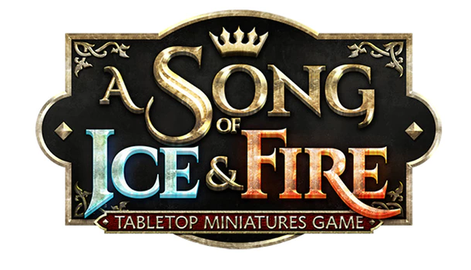

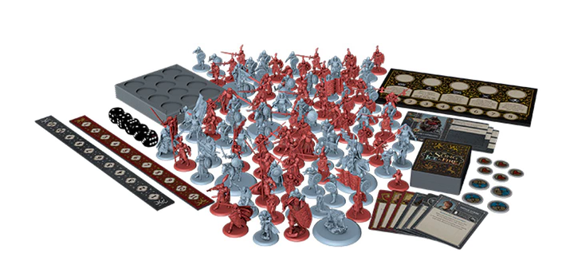

**A Song of Ice & Fire: Tabletop Miniatures Game** is a competitive miniatures game for two or more players. Each player controls one of the Great Houses of Westeros, commanding battlefield units, recruiting legendary Heroes, and manipulating the political stage, in the attempt to claim the greatest prize of all: *The Iron Throne*. Featuring *House Stark* and *House Lannister*, the **Starter Set** comes with over one hundred amazing, **preassembled**miniatures that are **ready to play** out of the box! All-new sculpts are based off original art created for the game by our crew under the direct supervision of **George R.R. Martin** and **Dark Sword Miniatures**, to ensure that the game delivers what fans have been envisioning for years.

The **Stark vs Lannister Starter Set** is a perfect introduction to a new miniatures game. With accessible and streamlined gameplay designed by **Eric M. Lang** and **Michael Shinall**, *A Song of Ice and Fire: Tabletop Miniatures Game* features 5 different Game Modes, Army Building and Customization options, and choices of Commanders and Attachments. This Set packs a lot of gameplay for 2 players!

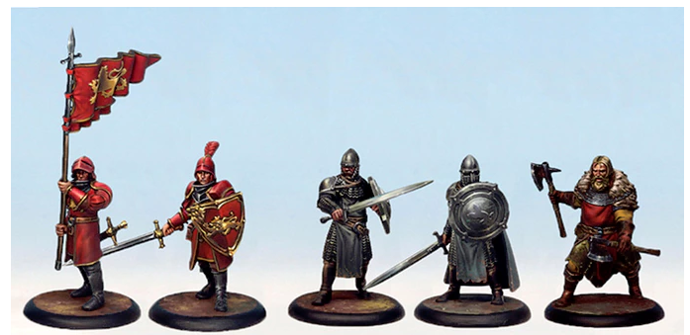

*An example of the Starter Set miniatures painted. Note that minis come unpainted!*

*Here's everything that's been added to the basic Hand of the King pledge:*

***Starks vs. Lannister Starter Set includes the following miniatures:***

* 24x Stark Sworn Swords
* 24x Lannister Guards
* 12x Umber Berserkers
* 12x Lannister Halberdiers
* 12x The Mountain's Men
* 4x Stark Outriders
* 6x Attachments
* 8x Characters
* 1x Grey Wind